BAYES RULE:

**Bayes Rules**

Rev Thomas Bayes

**Quiz: Cancer Test**

The question being asked is this: 1% of the population has cancer. Given that there is a 90% chance that you will test positive if you have cancer and that there is a 90% chance you will test negative if you don't have cancer, what is the probability that you have cancer if you test positive?

Example:

P(C) = 0.01

Test:

90% positive if you have Cancer 🡪 Sensitivity

90% negative if not have Cancer 🡪 Specitivity

90%, 8%, or 1%

Ans: 8%

**Quiz: Prior And Posterior**

CORRECTION: From 0:45 onward, the posterior for the cancer case should be written as P(C, Pos) instead of P(C|Pos), and the one for the non-cancer case should read P(~C, Pos) instead of P(~C|Pos).

Bayes Rule:

Prior Probability . Test Evidence 🡪 Posterior Probability

Prior: P(C) = 0.01

Joint🡪

P(C,Pos) = P(C ). P(Pos|C)

P(-C,Pos) = P(-C ). P(Pos|-C)

P(Pos|C) = 0.9

P(Neg|C) = 0.9 P(Pos|-C) = 0.1

Calculate Values:

P(C, Pos) = P(C ). P(Pos|C) = 0.009

P(-C, Pos) = P(-C ). P(Pos|-C) = 0.099

**Quiz: Normalizing 1-3**

Normalizes = P(Pos)

= P(C, Pos) + P(-C, Pos)

= 0.009 + 0.099

= 0.108

Posterior :

P(C| Pos) = P(C, Pos) / P(Pos)

= 0.009/ 0.108

= 0.0833

P(-C| Pos) = P(-C, Pos) / P(Pos)

= 0.099/ 0.108

= 0.9166

P(C| Pos) + P(-C| Pos) = 1

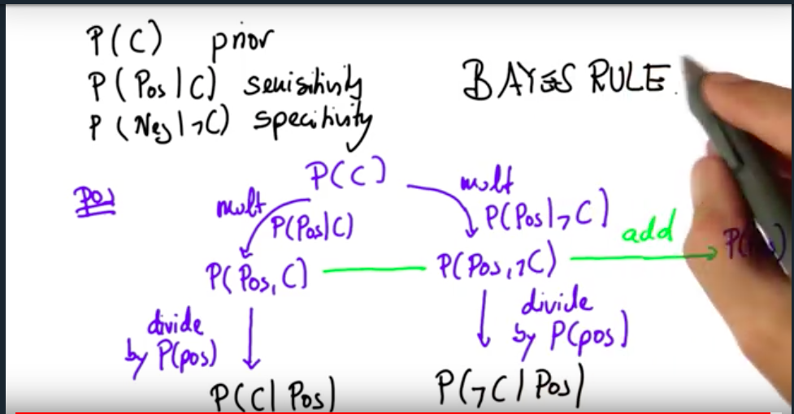

Negative Results:

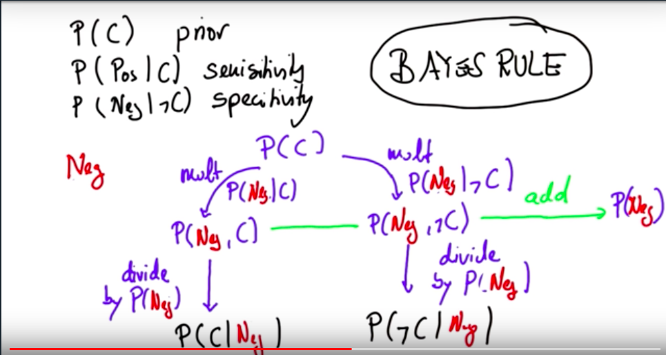

Example:

P(C) = 0.01 P(-C) = 0.99

P(Pos|C) = 0.9 P(Neg|C) = 0.1

P(Neg|-C) = 0.9 P(Pos|-C) = 0.1

Calculate Values:

P(C, Neg) = P(C ). P(Neg|C) = 0.001*0.1 = 0.001

P(-C, Neg) = P(-C ). P(Neg|-C) = 0.99*0.9 = -.891

P(Neg) = 0.001 + 0.891 = 0.892

P(C|Neg) = 0.0011

P(-C|Neg) = 0.9988

**Quiz: Disease Test 1-6**

Example:

P(C) = 0.1 P(-C) = 0.9

P(Pos|C) = 0.9 P(Neg|C) = 0.1

P(Neg|-C) = 0.5 P(Pos|-C) = 0.5

***Test: Negative***

Calculate Values:

P(C, Neg) = P(C ). P(Neg|C) = 0.1*0.1 = 0.01

P(-C, Neg) = P(-C ). P(Neg|-C) = 0.9*0.5 = 0.45

P(Neg) = 0.01 + 0.45 = 0.46

P(C|Neg) = 0.01/0.46 = 0.0217

P(-C|Neg) = 0.45/0.46 = 0.9782

***Test: Positive***

Calculate Values:

P(C, Pos) = P(C ). P(Pos|C) = 0.1*0.9 = 0.09

P(-C, Pos) = P(-C ). P(Pos|-C) = 0.9*0.5 = 0.45

P(Pos) = 0.09 + 0.45 = 0.54

P(C|Pos) = 0.09/0.54 = 0.1666

P(-C|Pos) = 0.45/0.54 = 0.8333

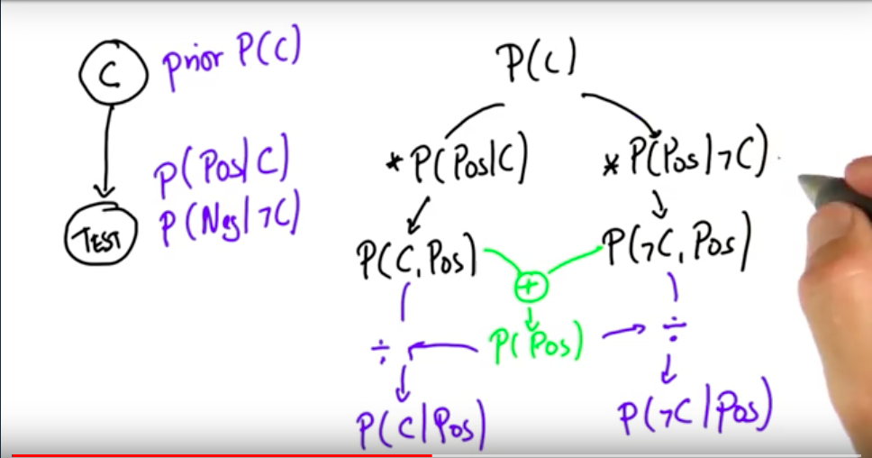

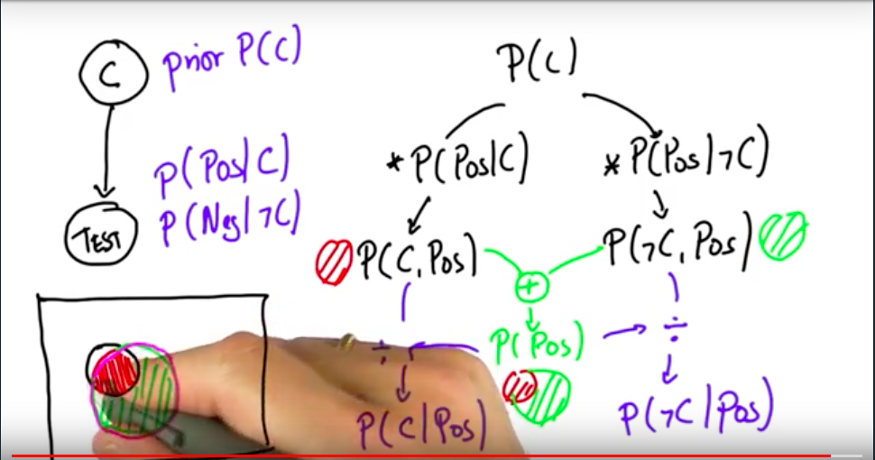

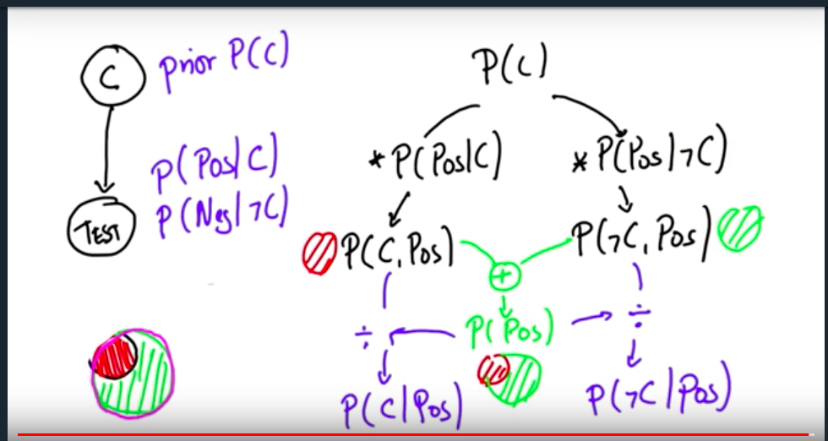

**Quiz: Robot Sensing 1**

**Step by Step Walkthrough**

The step-by-step breakdown of the solution is pretty quick. Let's recap what's covered in the solution video.

Let's start with what we know:

**Prior Probabilities**

The robot is perfectly ignorant about where it is, so prior probabilities are as follows:

*P*(at red)=0.5

*P*(at green)=0.5

**Conditional Probabilities**

The robot's sensors are not perfect. Just because the robot sees red does **not** mean the robot is at red.

*P*(see red∣at red)=0.8

*P*(see green∣at green)=0.8

**Posterior Probabilities**

From these prior and posterior probabilities we are asked to calculate the following posterior probabilities after the robot sees red:

*P*(at red∣see red)

*P*(at green∣see red)

and as a reminder, Bayes' rule looks like this:

*P*(*A*∣*B*)=

*P*(*B*)

*P*(*B*∣*A*)⋅*P*(*A*)

or, if we want to use our "versions" of A and B (for posterior #1)...

*P*(at red∣see red)=

*P*(see red)

*P*(see red∣at red)⋅*P*(at red)

Now, we can read two of those terms from what we already know about our prior and conditional probabilities which means we can rewrite this as...

*P*(at red∣see red)=

*P*(see red)

0.8⋅0.5

But we still have one unknown! What was the probability that we would see red? The answer is 0.5 and there are two ways I can convince myself of that. The first is intuitive and the second is mathematical.

**Why is P(see red) 0.5?**

**Argument 1: Intuitive**

Of course it's 0.5! What else could it be? The robot had a 50% belief that it was in red and a 50% belief that it was in green. Sure, its sensors are unreliable but that unreliability is symmetric and **not** biased towards mistakenly seeing either color.

So whatever the probability of seeing red is, that will also be the probability of seeing green. Since these two colors are the only possible colors the probability MUST be 50% for each!

**Argument 2: Mathematical (Law of Total Probability)**

There are exactly two situations where the robot would see red.

When the robot is in a red square and its sensors work correctly.

When the robot is in a green square and its sensors make a mistake.

I just need to add up these two probabilities to get the total probability of seeing red.

*P*(see red)=*P*(at red)⋅*P*(see red∣at red)+*P*(at green)⋅*P*(see red∣at green)

I can read these quantities from above!

*P*(see red)=0.5⋅0.8+0.5⋅0.2

*P*(see red)=0.4+0.1

*P*(see red)=0.5

**Robot Sensing 1:**

P(R) = P(G) = 0.5

P(see R| at R) = 0.8

P(see G| at G) = 0.8

Case: Sees Red

Posterior:

P(at R | see R) = ?

P(at G | see R) = ? { P(- at R | see R) = ? }

Calculate Values:

P(R) = 0.5 P(-R)=P(G) = 0.5

P(see R| at R) = 0.8; P(see G| at R)= 0.2

P(see G| at G) = 0.8; P(see R| at G)= 0.2= P(see R |-R)

P(R, see R) = P(R ). P(see R |R) = 0.5*0.8 = 0.40

P(-R, see R) = P(-R ). P(see R |-R) = 0.5*0.2 = 0.10

P(see R) = 0.40 + 0.10 = 0.5

P(R| see R) = 0.4/0.5 = 0.8

P(-R| see R) = 0.1/0.5 = 0.2

**Robot Sensing 2:**

P(R) = 0

P(G) = 1

P(see R| at R) = 0.8

P(see G| at G) = 0.8

Case: Sees Red

Posterior:

P(at R | see R) = ?

P(at G | see R) = ? { P(- at R | see R) = ? }

Calculate Values:

P(R) = 0 P(-R)=P(G) = 1

P(see R| at R) = 0.8; P(see G| at R)= 0.2

P(see G| at G) = 0.8; P(see R| at G)= 0.2= P(see R |-R)

P(R, see R) = P(R ). P(see R |R) = 0*0.8 = 0

P(-R, see R) = P(-R ). P(see R |-R) = 1*0.2 = 0.2

P(see R) = 0 + 0.2 = 0.2

P(R| see R) = 0/0.2 = 0

P(-R| see R) = 0.2/0.2 = 1

**Robot Sensing 3:**

P(R) = P(G) = 0.5

P(see R| at R) = 0.8

P(see G| at G) = 0.5

Case: Sees Red

Posterior:

P(at R | see R) = ?

P(at G | see R) = ? { P(- at R | see R) = ? }

Calculate Values:

P(R) = 0.5 P(-R)=P(G) = 0.5

P(see R| at R) = 0.8; P(see G| at R)= 0.2

P(see G| at G) = 0.5; P(see R| at G)= 0.5= P(see R |-R)

P(R, see R) = P(R ). P(see R |R) = 0.5*0.8 = 0.4

P(-R, see R) = P(-R ). P(see R |-R) = 0.5*0.5 = 0.25

P(see R) = 0.4 + 0.25 = 0.65

P(R| see R) = 0.4/0.65 = 0.6153

P(-R| see R) = 0.25/0.65 = 0.3846

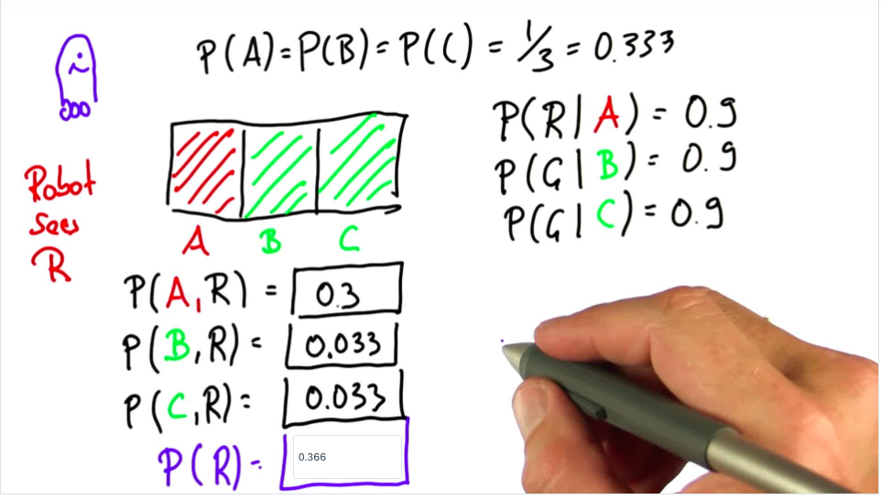

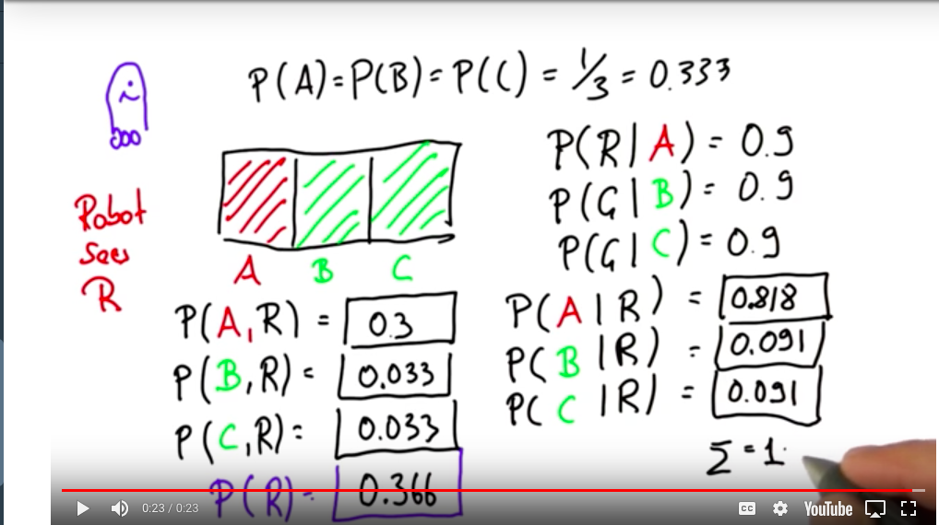

**Generalizing**

**Sebastian at Home Example:**

P(gone) = 0.6

P(home) = 0.4

P(rain|home) = 0.01

P(rain|gone) = 0.3

P(home|rain) = ?

Calculate:

P(home) = 0.4 P(-home)=P(gone) = 0.6

P(see R| at H) = 0.01; P(see G| at H)= 0.99

P(see G| at G) = 0.7; P(see R| at G)= 0.3= P(see R |-H)

P(H, see R) = P(H ). P(see R |H) = 0.4*0.01 = 0.004

P(-H, see R) = P(-H ). P(see R |-H) = 0.6*0.3 = 0.18

P(see R) = 0.004 + 0.18 = 0.184

P(H| see R) = 0.004/0.184 = 0.0217

P(-H| see R) = 0.18/0.184 = 0.9782

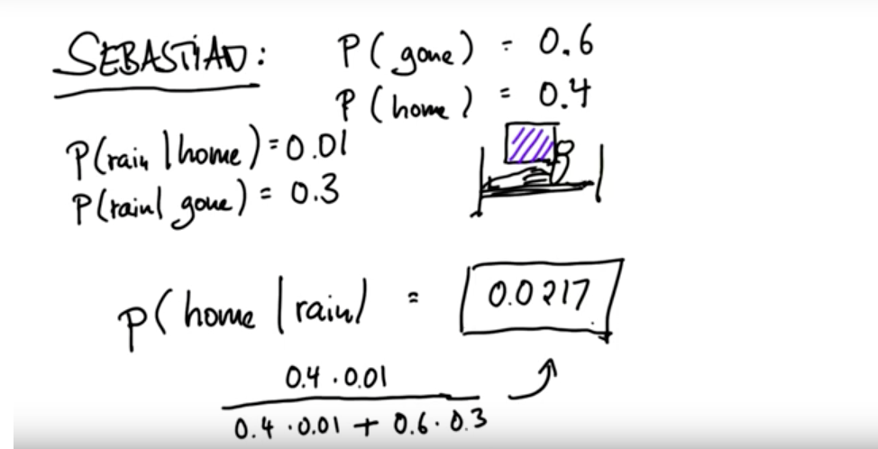

**Learning Objectives - Conditional Probability**

We use the notation where

*P*(*A*) means "the probability of A"

*P*(¬*A*) means "the probability of NOT A"

*P*(*A*,*B*) means "the probability of A **and** B" and

*P*(*A*∣*B*) means "the probability of A **given** B.

**QUESTION 1 OF 5**

If A and B are **independent** events and P(A) = 0.2 and P(B) = 0.1, what is P(A,B)?

0.02

That's right. Probabilities just multiply for independent events.

**QUESTION 2 OF 5**

If A and B are **NOT independent** events, and P(A) = 0.2 and P(B) = 0.1, what is P(A, B)?

Not enough information to answer.

**Thanks for completing that!**

That's right. We need more information...

**QUESTION 3 OF 5**

If A and B are NOT independent events, and P(A) = 0.2, P(B) = 0.1, and P(B|A) = 0.3 what is P(A|B)?

0.6

**Thanks for completing that!**

That's right

**Note:**

The remaining questions deal with two coins.

**Coin 1** is fair. When flipped it has a **probability of 0.5 for heads and 0.5 for tails.**

**Coin 2** is biased. When flipped it has a **probability of 0.9 for heads and 0.1 for tails.**

Ans: 0.25+0.45= 0.65 ~ 0.7

**Thanks for completing that!**

That's right.

**QUESTION 5 OF 5**

You grab a coin at random and flip it twice.

What's the probability that it comes up tails both times?

0.5*0.5*0.5 + 0.5*0.1*0.1 = 0.125 + 0.005 = 0.13

**Thanks for completing that!**

That's right.

**Reducing Uncertainty**

Self – Driving Cars Example

Gives information: Position, Movement & Environment

**Bayes' Rule And Robotics**

**Initial Scenario**

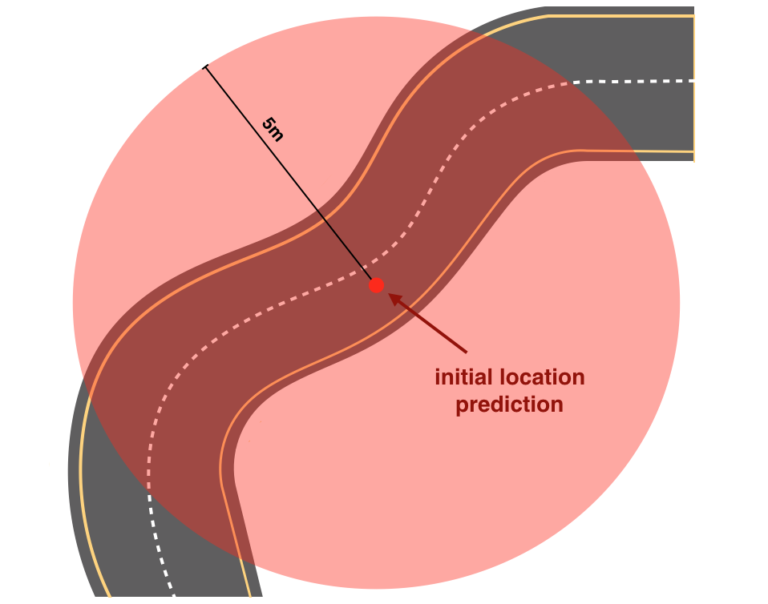

Map of the road and the initial location prediction

We know a little bit about the map of the road that our car is on (pictured above). We also have an initial GPS measurement; the GPS signal says the car is at the red dot. However, this GPS measurement is inaccurate up to about 5 meters. So, the vehicle could be located anywhere within a 5m radius circle around the dot.

**Sensors**

Then we gather data from the car's sensors. Self-driving cars mainly use three types of sensors to observe the world:

**Cameras**, which records video,

**Lidar**, which is a light-based sensor, and

**Radar**, which uses radio waves.

All of these sensors detect surrounding objects and scenery.

Autonomous cars also have lots of **internal sensors** that measure things like the speed and direction of the car's movement, the orientation of its wheels, and even the internal temperature of the car!

**Sensor Measurements**

Suppose that our sensors detect some details about the terrain and the way our car is moving, specifically:

The car could be anywhere within the GPS 5m radius circle,

The car is moving upwards on this road,

There is a tree to the left of our car, and

The car’s wheels are pointing to the right.

Knowing only these sensor measurements, examine the map below and answer the following quiz question.

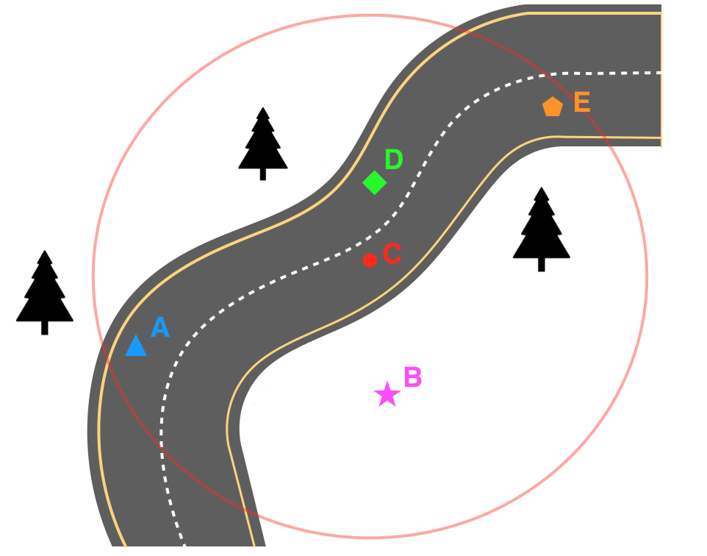

Road map with additional sensor data

**QUIZ QUESTION**

After considering the sensor measurements and the initial location prediction, which point on the above map is the best estimate for our car’s location?

A

**Thanks for completing that!**

That's right! Since we know the car is moving up this road with its wheels turned to the right, it's likely on a right-curved part of the road, which are points A and E. Point A has a tree right to its left, so this is the best guess for our car's location! In real-world scenarios, we'll have a lot more sensor data to work with, which can help us accurately localize a car.

**CONTINUE**

**Using Sensor Data**

**Learning Objectives - Bayes' Rule**

**Prior knowledge**

**For questions 1-3, assume you already have the following knowledge**:

You’re interested in finding out the probability of a car stopping if it sees a yellow traffic light.

Past data tells you that the probability of a car stopping at a traffic light intersection is *P*(*S*)=0.40.

You also know that the past probability of a traffic light being yellow (as opposed to red or green) is*P*(*Y*)=0.10.



Car stopping at a yellow light

**QUESTION 1 OF 5**

When a car is stopped at an intersection, data shows that 12% of the time the light is yellow. So if we know a car is stopped, there's a 12% chance the light is yellow. This is called a conditional probability.

Given P(S) and P(Y) above, how would you represent this conditional probability in notation?

ANS:

P(Y|S) = 0.12

**Thanks for completing that!**

That's right. Given that a car is stopped, we know that it is 12% likely (0.12 in decimal value) that the light is yellow, which is given by the notation P(Y|S). Which can be read as "Probability of Yellow given a Stopped car."

**QUESTION 2 OF 5**

Using what you know from question 1, answer the following: if the traffic light is yellow, what is the chance that the car will stop?

Solution:

P(Stop|Yellow) = P(Yellow|Stop) *P(Stop) / P(Yellow)

= 0.12*0.4/ 0.10 = 0.48

0.48

**Thanks for completing that!**

That's right. Using Bayes' rule, we know that

P(S|Y) = P(Y|S)*P(S) / P(Y)

P(S|Y) = 0.12*0.4 / 0.1 = 0.48

And intuitively this value seems about right; a car should stop about half the time when faced with a yellow light.

**QUESTION 3 OF 5**

Knowing that a car stopping at an intersection and the presence of a yellow traffic light are related events, what are P(S) and P(Y) known as?

Prior probabilities

**Thanks for completing that!**

That's right.

**Questions 4 and 5 are different scenarios.**

**Prior knowledge for question 4:**

On a four-lane highway, cars are either going fast or not fast. Faster cars should go in the leftmost lanes.

At any given time, 20% of cars are in the left-most lane.

Overall, 40% of cars on the highway are classified as going fast.

Out of all the cars in the leftmost lane, 90% are going fast.

**QUESTION 4 OF 5**

Given the above information, if a car is going fast, what is the probability that it will be in the leftmost lane?

P(Left|Fast) = P(Fast|Left) *P(Left) / P(Fast)

= 0.9 * 0.2 / 0.4

= 0.45

**Thanks for completing that!**

That's right. Using Bayes' rule, we know that 0.9*0.2/0.4 = 0.45.

Bayes' rule is not only used to incorporate sensor data into an estimate; it’s also often used to incorporate test data into a medical diagnosis.

**Prior knowledge for question 5:**

* 1% of all people have cancer.
* 90% of people who have cancer test positive when given a cancer-detecting blood test, meaning the test detects cancer 90% of the time.

5% of people will have false positives, meaning that 5% of the time, this test will produce a positive result when people do not have cancer.

Solution:

P(C ) = 0.01

P( Pos|C) = 0.9

P( -C | Pos) = 0.05

0.9 * 0.01 = 0.0090

0.99*0.05 = 0.0495

.0090/ .0585= 0.1538

**Thanks for completing that!**

That's right. This one was tricky; if you answered all these questions correctly, you are ready to [skip to the next lesson](https://classroom.udacity.com/nanodegrees/nd113/parts/8324d3fb-43ed-4e46-921a-09be81e3b518/modules/bb316d89-3a59-4093-b62d-f36d7822e530/lessons/9986b101-885e-4ece-b522-b70a8b2cceed/concepts/c6d67452-e114-4e6a-bf2c-f61c940814e0) (Programming Probability 2).

import numpy as np

#array is exclusive of outer bound

#probability of values in array are equal by default

np.random.randint(0,2, size=10000).mean()

#array starts by default from 0

#array is always exclusive of upper bound

np.random.randint(2, size=10000).mean()

#array p specifies probabilities

#used for biased choices

np.random.choice([0,1], size=10000, p=[0.8,0.2]).mean()

**CONTINUE**